**IT DEPARTMENT PROCESS**

**ADMIN MASTER ENTRY - TAILYOU**

1. **Form Design**
2. **Work Order Description**
3. **Table Name**
4. **Conditions**

**Work Order Year: 2018-19**

**TYPE:INTERNAL Created By: RAMESH M**

**1. FORM DESIGN**

**1.1 Category Submission Page:**

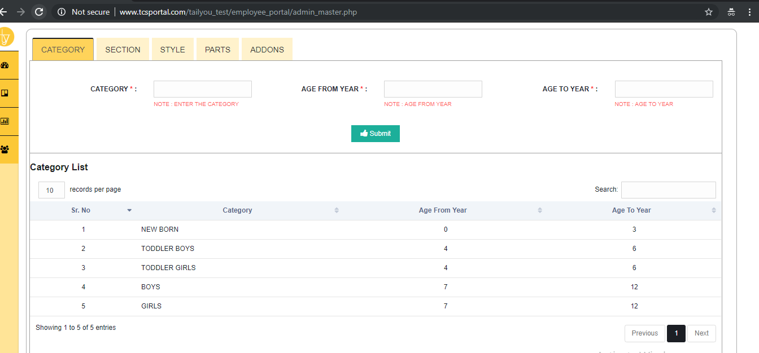

**1.2Section Submission page:**

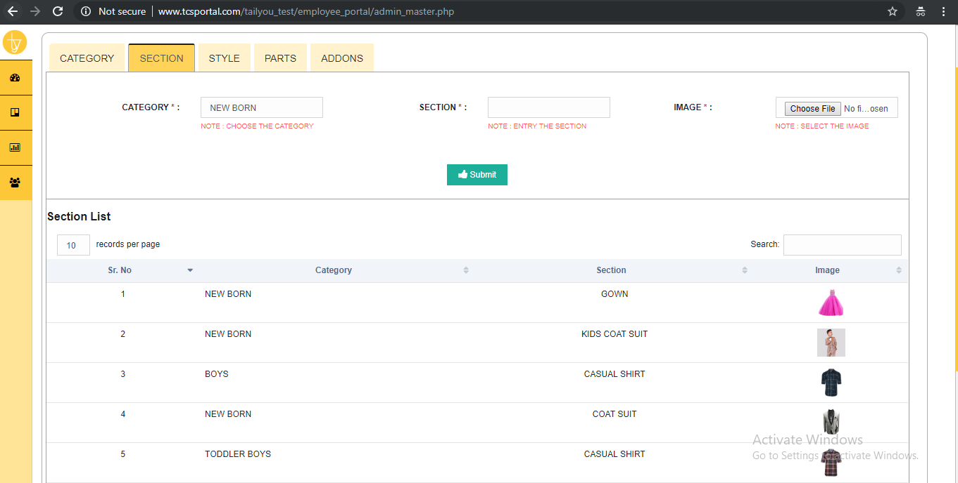

**1.3 Style Submission Page:**

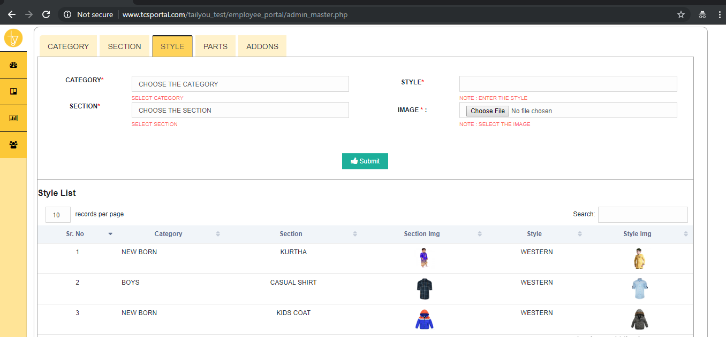

**1.4 Parts Submission Page:**

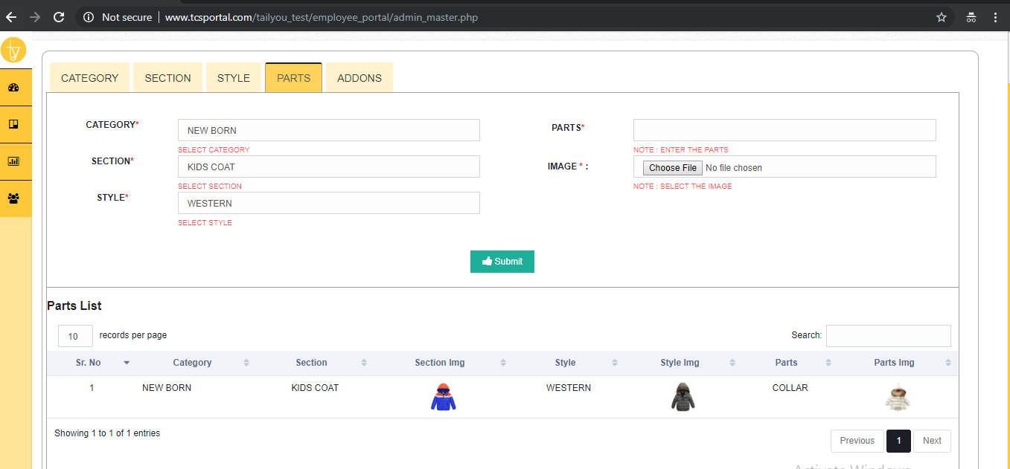

**1.5 ADDONS Submission Page:**

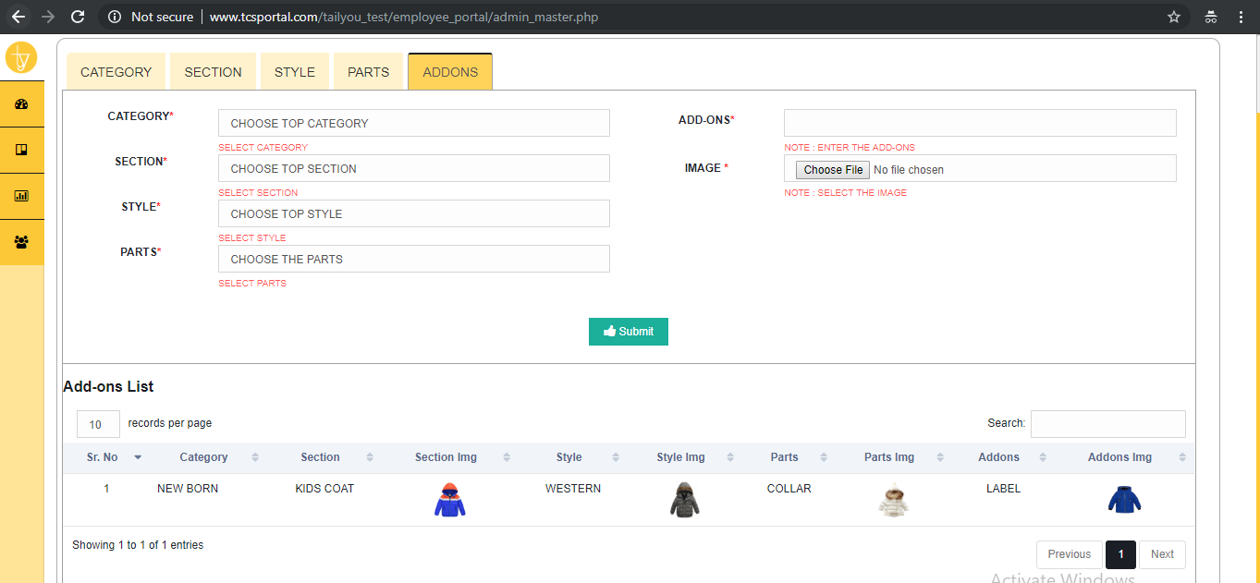

1. **DESCRIPTION**

Insert datas to Category, Section, Styles, Parts and Addons.

**3. TABLE NAME**

**3.1 Main Table:**

* TLU_MASTER
* TLU_TYPE_MASTER

**4. CONDITIONS**

1. WHERE TLMSTYP='1'
2. WHERE TLMSTYP='2'
3. WHERE TLMSTYP='3'
4. WHERE TLMSTYP='4'
5. WHERE TLMSTYP='5'